Background of the problem

Many businesses now a day sprung rapidly due to high demands of people’s needs one business that takes advantage of this are the retail stores. But unfortunately retail stores that run on this day currently uses manual method of doing their transactions such as billing, computation of sales, organizing of inventories and generating daily sales reports. As our client the FEELMORE Enterprise Bacoor Branch also uses manual method of doing their transaction. They are having difficulties in many reasons such as having more than 1,000 products of sports equipment and musical instrument which they sell 40 plus items a day, wherein they cannot track their inventory because they do not own the buy products but they also sent products and receive from other branches. And they cannot keep track on their products and keep the records on which product is being pulled in and out. Monitor which goods are needed to be restocked and eliminate the access of every personnel, mainly 4 personnel the salesclerk, manager, admin, stock holder in opening their data. The problem in Point of Sale that they are experiencing is that they have so many procedures in recording their sale’s transaction. Whereas at first, they get all the receipt from that day and write it on a log book, and then type it on excel. Because of that they cannot track their own products because of miscalculations on log book and excel. And because of that the owner of FEELMORE Enterprise Mr Celbert Buliag plans to have a computerized system for their Bacoor Branch to give better services of transaction and to have easy access to all of their records at the same time giving them security.

Overview of the current state of the technology

As technology advances so does businesses and just like technology our client also advances by opening a new branch at Bacoor. They both sell sports equipment and musical instruments just like their other branches. As our client currently uses manual system in their newly opened branch their process in transaction and monitoring their good includes listing down all the orders, counting and organizing customer payments. As their process in doing their transaction when a customer buys from then a customer goes to their store and look for the item they want to purchase and present it to the cashier whereas the cashier or sales clerk writes down a receipt for the customer and stick their copy in a bill holder and give the original receipt to the customer and before closing the sales clerk writes the receipt on their log book to insure that it is recorded. Also they use a semi manual way of data entry in their inventory whereas they use an excel in this process they check all the records in the log book and check if the products are still in count and that the products matched their inventory and at their log book.

## Objectives of the study

The proponents plan to meet the following objectives upon finishing the project:

The system helps increase the productivity of the company giving a result of helping the company to not manually write reports. The system ensures accuracy and reliability in recording sales transactions and also be beneficial to the customers by precisely calculating their bills resulting in customers being served better and faster.

The study aims to provide FEELMORE Enterprise – Bacoor branch with enhance and more modern alternative in doing their sales. Specifically, it aims to provide real-time sales data, develop a system that easily generates reports to user queries, and create a database that would organize necessary details involving the sales.

Specific Objectives

1. To design and develop a File maintenance module that will handle the information’s of FEELMORE Enterprise Bacoor Branch. The proposed system has the ability to create and delete data’s regarding the data of employees and products whereas the employees’ data which can be updated so restrictions are enabled and only assigned employees can use the system and also the proposed system has the capability to add, update and delete the basic information of products.
2. To design and develop a Point of Sale module for the transactions of FEELMORE Enterprise Bacoor Branch that will track all the transaction. The proposed system can lessen the miscalculations and inaccuracy of quantity of items being sold by automatically computing the purchased item by using the barcode scanner as the main input device. And also the system can track and save all the transaction in the sales database.
3. To design and develop an Inventory management module for FEELMORE Enterprise - Bacoor Branch that will monitor the quantity level of items. FEELMORE Enterprise - Bacoor Branch not only sells products to their customers but also send off some of their products to their other branches and also other branches sends them their product stocks. Whereas the proposed system will be reliable in tracking how many products FEELMORE Enterprise has shipped and how many products they still hold and that the proposed system can also eliminate the need of constantly encoding lengthy details of product by having an inventory database.
4. To design and develop a report module that will generate accurate reports for FEELMORE Enterprise Bacoor Branch. The proposed system has the capability to generate accurate reports of transactions done or the sales report and also show all the updates an employee has done to the system or the audit trail whereas the only one who has the capability to see this reports are the owner whereas he can access it instantly and accurately and see all the reports.

Scope and limitations of the study

The main concern of the developer is to ensure operational feasibility of the system. In this regard, they assure that the system is operationally feasible and practical application, they guarantee that the system can easily be understood by the user/owner to the understandable language as provided of the system. The proposed study is limited to keeping track of sales of FEELMORE Enterprise - Bacoor Branch. It is concerned with the reports for the management of the business. Reports which present labor auditing are not anymore within the scope of the study. The limitations of the study include not involving the probability that customer’s would carry out credit card transactions. Also, credit is not viable to customers who directly place orders in the counter.

Scope:

The point of sale and inventory system with barcode scanner for FEELMORE Enterprise - Bacoor Branch has the capability to manipulate all the data given by the users, it can monitor the saved data and also add, update and delete data’s and to much better elaborate that the system focuses on the following processes:

The File Maintenance module consists of: Employee maintenance module this gives the admin to add, update and delete which personnel of FEELMORE Enterprise can use the system by assigning which username and password for a personnel of and assigning his/her designated task.

Category Maintenance module this gives the user to add, update and delete information about the category of products that FEELMORE Enterprise caters.

Supplier Maintenance t module his gives the admin the capability to add, update and delete the information of the suppliers of FEELMORE Enterprise.

Branch Maintenance module this gives the admin the capability to add, update and delete the information of the other branches of FEELMORE Enterprise.

Brand Maintenance module this gives the admin the capability to add, update and delete the information of the brand of products that FEELMORE Enterprise sells.

Point of Sale this module helps the employees to easily identify all the products and all its information by using the barcode scanner and saving the finished transaction on the database to ensure that the product stocks are being monitored.

Inventory maintenance module this will determine the total number of products that are currently in stock, it will determine the total number of products that are needed to be restock and this will helped fasten the saving of data product by saving it in a database.

Inventory stock Transfer this will determine the specify branch a product may be sent to and how many products other branches has sent to their branch.

Sales Report this helps the employees see all product sold in a day or the previous transactions.

Audit Trail this will determine the information about what the user has done in the system all the data that they added, updated and deleted will be recorded here.

The limitations of our system is that it will not support other operating system that can’t read executable files and the following are the list of processes that the system cannot do which is the system cannot take credit cards or checks and the system cannot reprint or scan receipts for refunded items.

# Literature Review

## Review of related literature, studies or systems

Foreign Literature

Also known as the point of service or POS, the point of sale is the exact point in a transaction when goods or services are provided to the customer and payment is rendered for those products. While the specifics of a point of sale system will vary somewhat from one situation to another, the final outcome is always the same. [Malcolm Tatum, 2010]

Point of sales (POS) software is a type of software that retail store use to calculate their sales and operate the cash drawer; it is a computerized cash drawer. Point of sales add up the sales total and calculate the change. When customer buy items from retail store, point of sales will minus or debit the amount of item sold in the inventory system. At minimum, POS should be able to handle sales and manage your inventory database. [Jane Harmon, 2010]

Local literature

We chose the study of Acopiado Sheena Mae, DaboDabo Teddy, Gomez Aithana Rosette and Santiago Kim Ivory which is Sales and Inventory System For Pharmacia Josefa Drugstore wherein the researcher have found that the drugstore is using manual system for sales and inventory as their current way of product transaction and monitoring which in result the records don’t correspond in their manually recorded data’s. Another problem is that the drugstore often forgot to record the products that have been sold. So the solution to these problems is making an automated or computerized sales and inventory system which it is capable of providing an easy access in sales and inventory conditions to customers and partners. Making this system can minimize their time period and can help them process their inventory easily. It is a hassle free and an easy access system. The system can add, and Delete data’s. It also has a transaction process so that in every product that the costumer will buy, will automatically recorded to the inventory.

Synthesis

The developer created a Point of Sale and Inventory Management System with Barcode Scanner for FEELMORE Enterprise Bacoor Branch is the fact that the system has the same objective stated by Malcolm Tatum and Jane Harmon which are to handle sales and manage the inventory database. Both statements are in agreement that a Point of Sale helps manage the overall computation. This study is to develop a system for FEELMORE Enterprise which has the capability to display all the sales done by the cashier, manage the inventory, give security by ensuring only authorized personnel can access the system and a billing which will compute all the products a customer has bought.

Technology now a day is not only used for entertainment but also to help in making work more convenient. Just like what Malcolm Tatum and Jane Harmon said point of sale is the exact point in a transaction when goods or services are provided to the customer and in which it has the capability to minus or debit the amount of item sold in the inventory system. Whereas the proposed system is not a rendered copy of other point of sale and inventory because the developer made the proposed system specifically for their client FEELMORE Enterprise whereas the system manages all the transaction done by the company and that the system can also manager all the products that where sent by other branches and also manages all the product the store has sent to other branches.

Methodology of the Study

Iterative Life Cycle Model

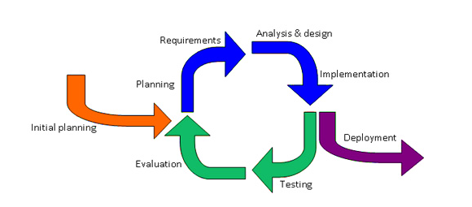An iterative life cycle model does not attempt to start with a full specification of requirements. Instead, development begins by specifying and implementing just part of the software, which can then be reviewed in order to identify further requirements. This process is then repeated, producing a new version of the software for each cycle of the model.This iterative life cycle model suits the development of this system as the processes involve on this cycle gives enough time to review and change the system in every step.

Figure 1.1 Iterative Life Cycle Model

Planning Phase

We initial an proposal for Software engineering have to secured for our instructor such approval for him and we search an company we found out FeelMore to be our host company and for their agreed in our proposal. After we gather interview about the Point of Sale with inventory, we examining and analysis their problem and need of their POS.

Analysis and Design

After we gather enough information we start analyzing and create system researchers learned that a computerize Point of Sale with Inventory System, with the ability to update retail price is needed by the company. A report of the products that came in and out of the business is also needed.

Implementation Phase

After the developers create a system, we ensure all the user will be trained to all specific modules, The Activities: construct software components, verify and test, convert data, train users and document the system, install the system.

The system we make will be initially tested after the development of it. After the initial and final testing, training will be implemented to the Owner and Crew for understanding of the use of the new Point of sale with inventory.

Maintenance Phase

The developers maintain the system to make sure that it is running smoothly. The developers could also make improvements or upgrades for the system when necessary. The developers give warranty of maintaining the efficiency of the system.

Hardware/Software

The proposed systemuses hardware such as a Laptop so that the developer can create the system and test if there are errors also for them to create the documentation to keep track of the data of the proposed system and use a printer to ensure that the documentation is printed. Other hardware use is a barcode scanner to ensure that the main requirement fits with the proposed system and a flash drive to ensure that the developer would have a backup file of their system and documentation to ensure that they would still have the system and documentation in case of the system being corrupted. The proposed systemuses software such as Visual studio in making the system such as the design of the system and its codes, MySQL Workbench in making a database, Microsoft Word in making the documentation and Google Chrome for searching data’s.

Point of Sale and Inventory Management System with Barcode Scanner for FEELMORE Enterprise - Bacoor Branch

Overview of the project

The apparently our host company currently using traditional manual system of sale service processing that of which includes an everyday set of recording and as old practice it is unreliable

Because someone forgets to write orders and sold of product it can affect the outcome of the records. The purpose of our system is to enhance the transaction in their Point of sale system or exist in the specific technology in there branch. The important regarding the technology is stops the long transaction of buying produce by using of our System. In our system we use Object-oriented C# programming language, MySQL Workbench as Database .etc. To accomplish the general problem all project. Our goal is must achieved top of the problem in solve it to the best way and fix the problem of our host in their Point of sale. After the instalment of the system we would continuously monitor the system and the establishment in order to maintain the quality of the system.

System design specification

The proposed system is composed of several forms such as the login form which will enable the user to input their username and password whereas if the username and password does not exists in the database or is invalid the system would not be accessed. In the main form, the user will see different modules such as the File maintenance module, Point of sale module, Inventory module and Report module. The system requires users that are trained to insure the system works to with its functionality and also it must be installed on a workstation that has the proper software and hardware requirements.

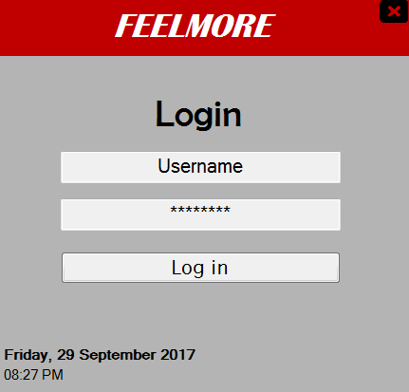

Figure 1 Login Form

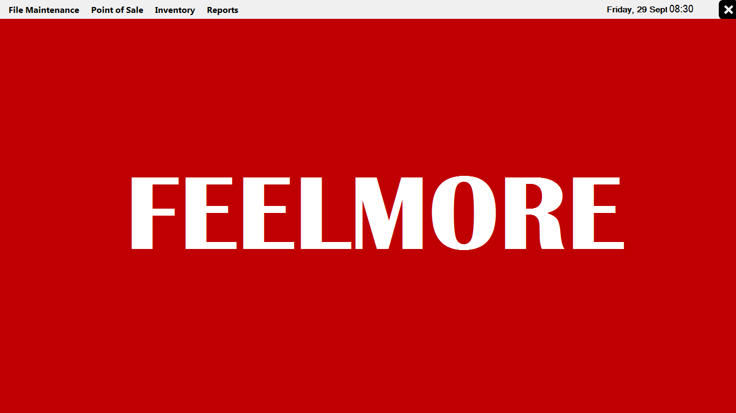

Figure 2 Main Form

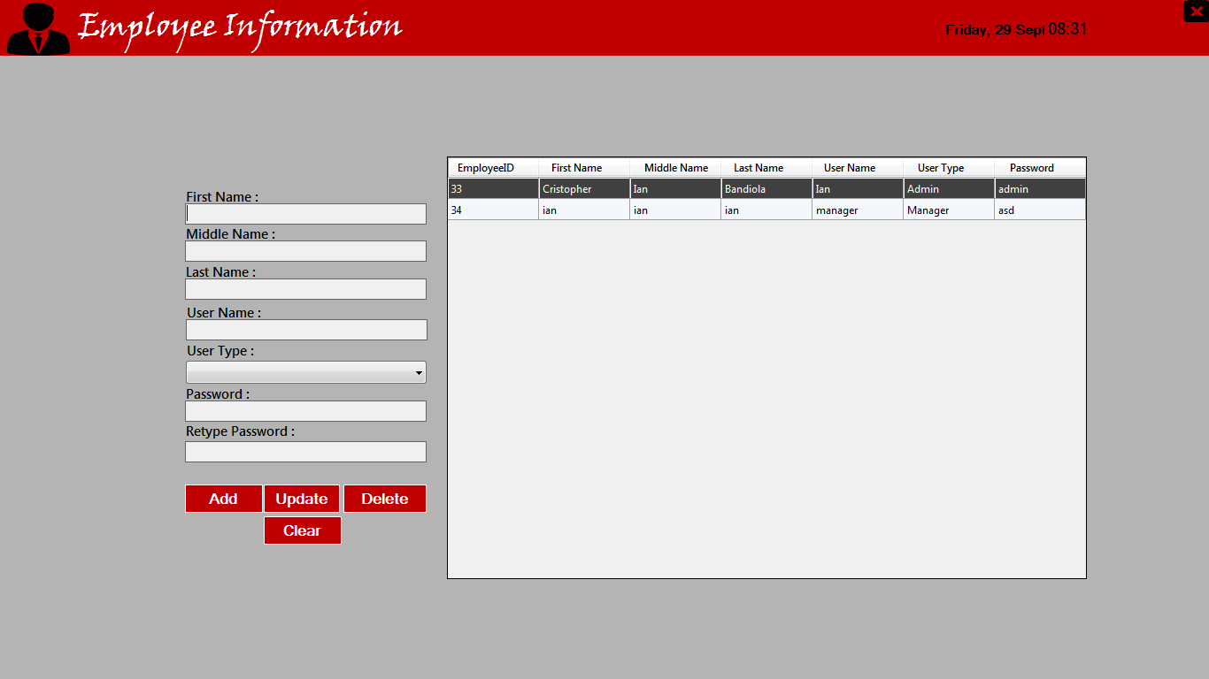

Figure 3 Employee Information Form

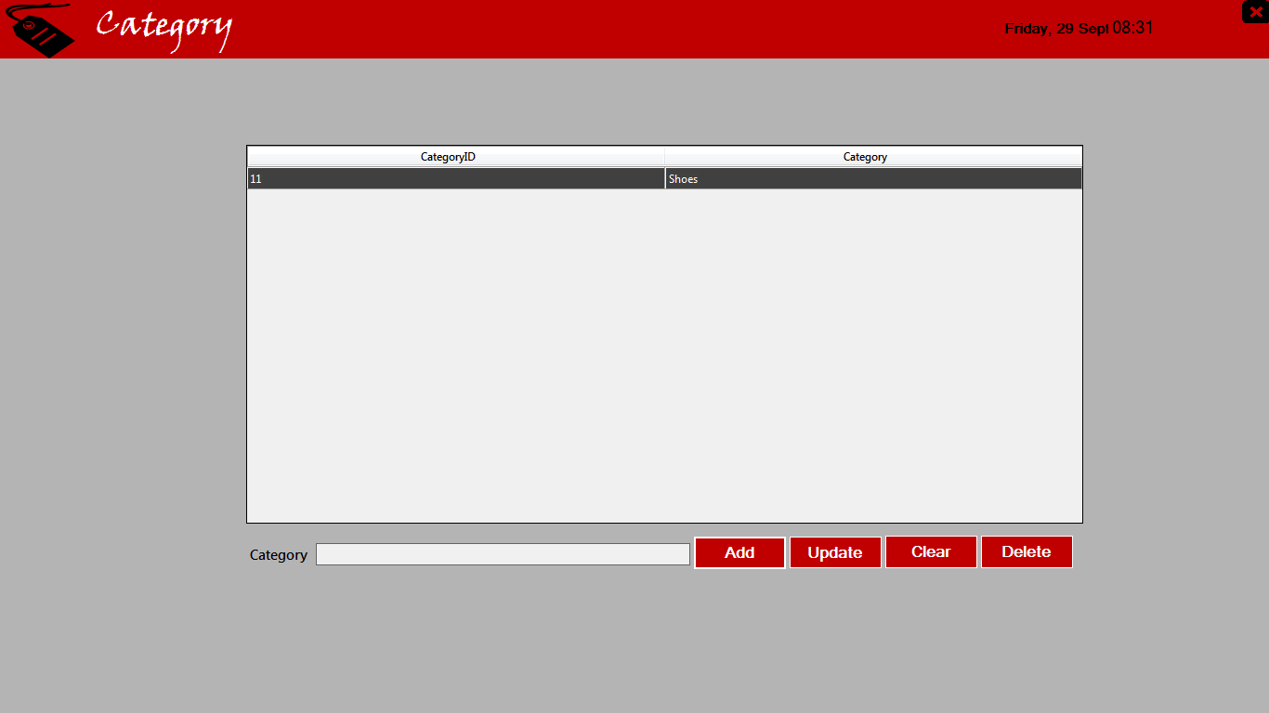

Figure 4 Category Form

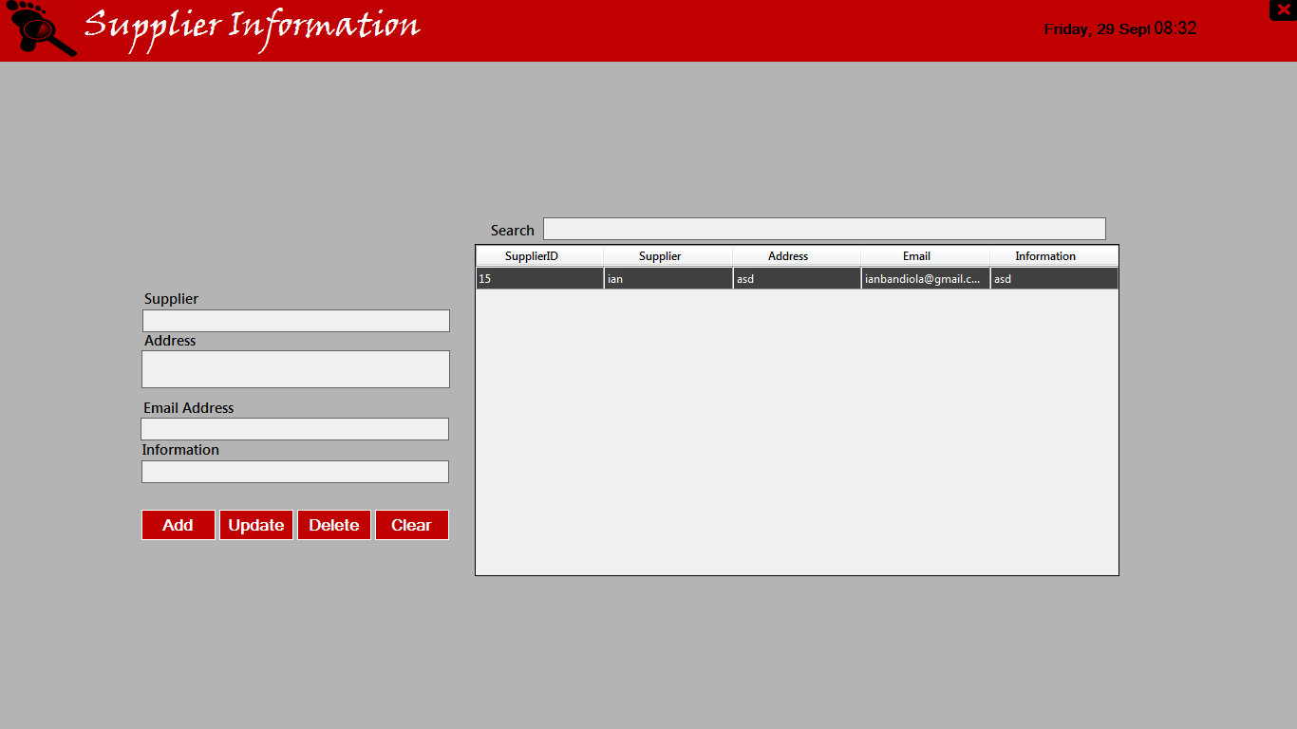

Figure 5 Supplier Information Form

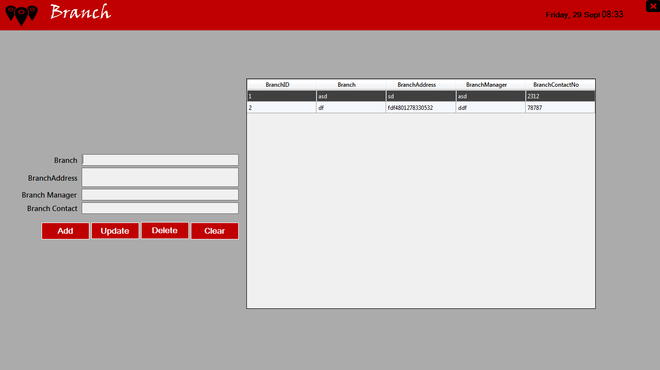

Figure 6 Branch Form

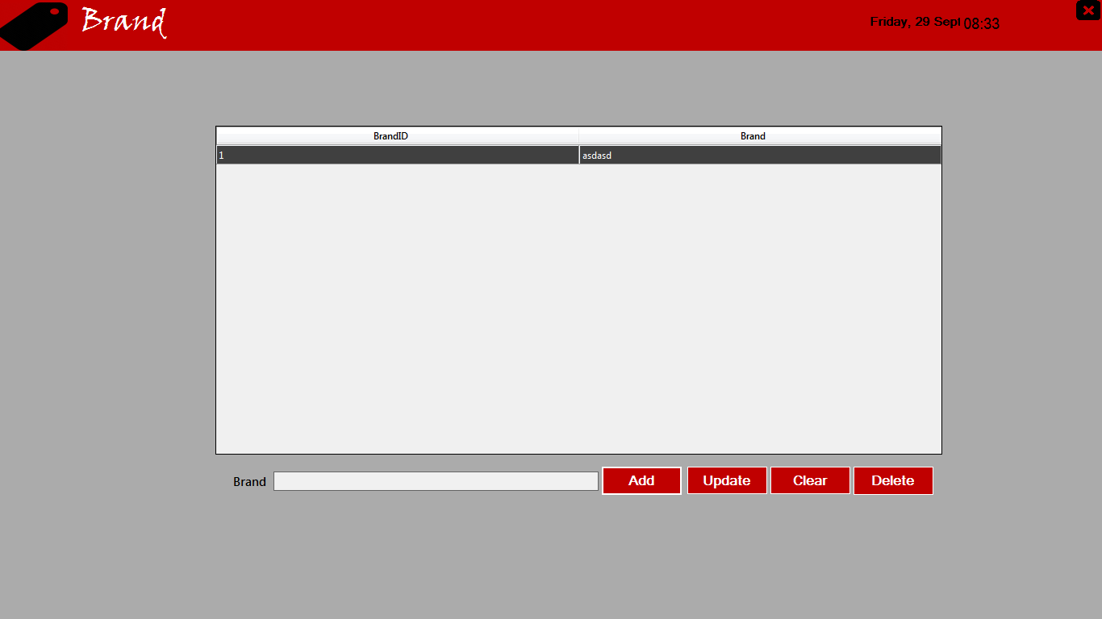

Figure 7 Brand Form

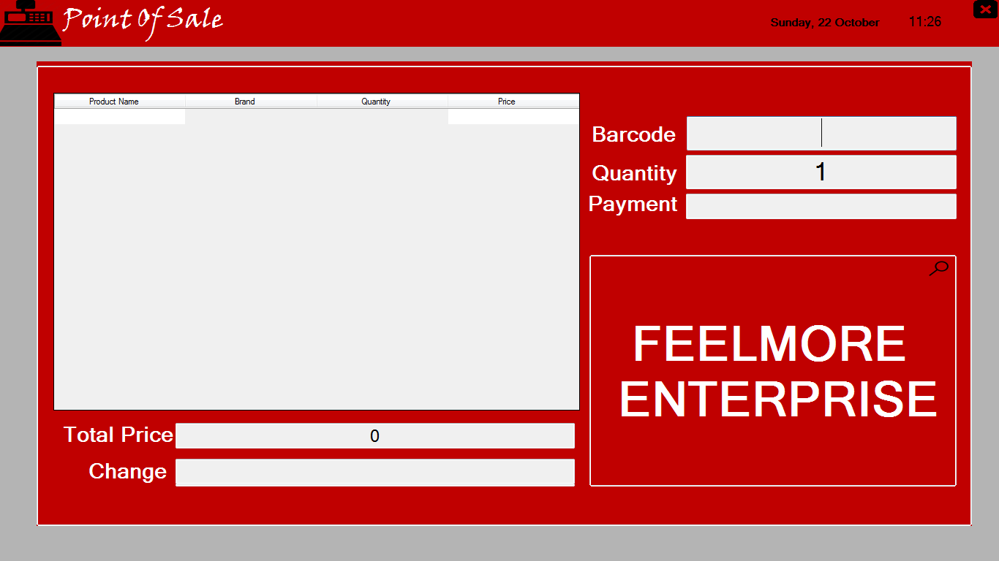

Figure 8 Point of Sale Form

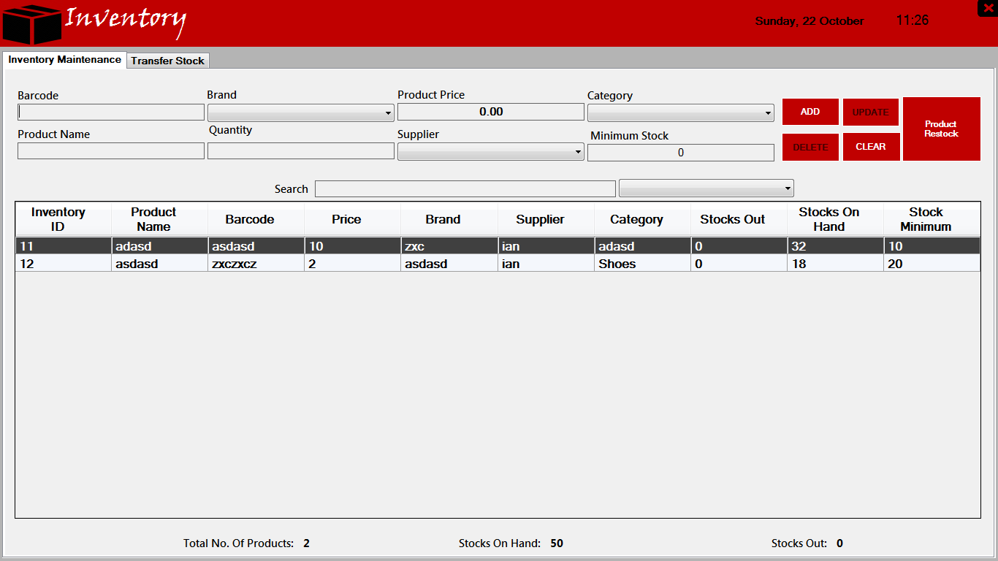

Figure 9 Inventory (Maintenance) Form

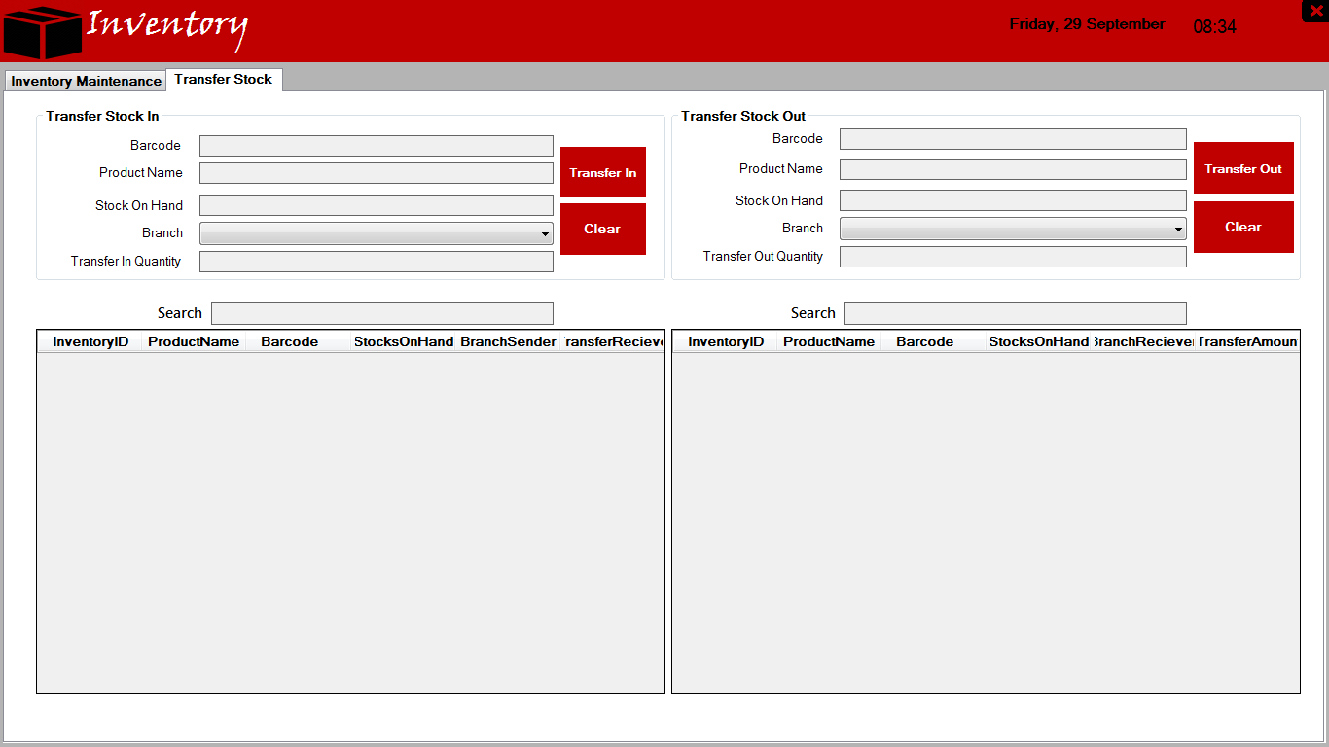

Figure 10 Inventory (Transfer Stock) Form

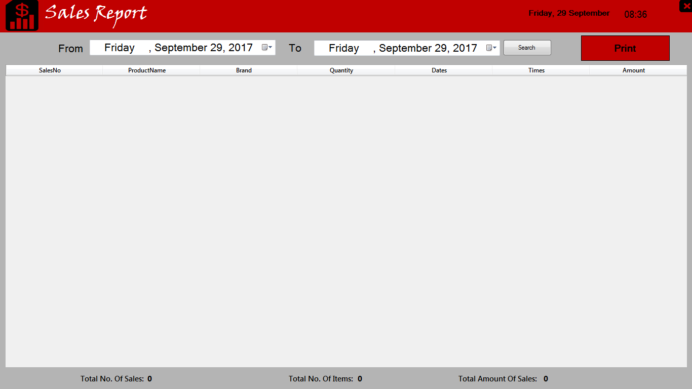

Figure 11 Sales Report Form

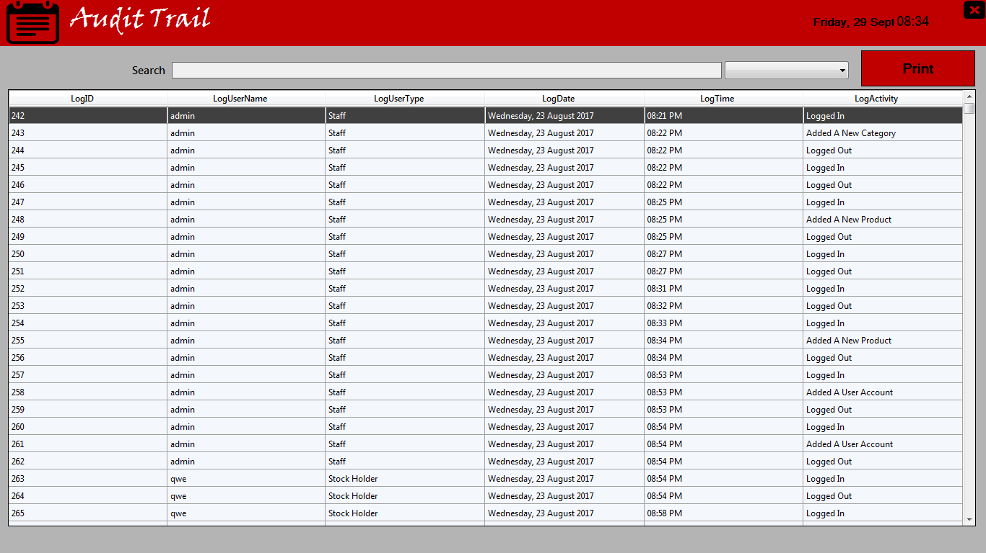

Figure 12 Audit Trail Form

Entity-relationship diagram (ERD) Database

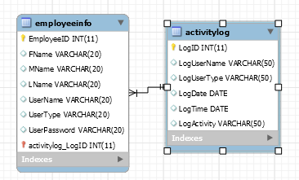

Diagram 1.1 Log in Transaction

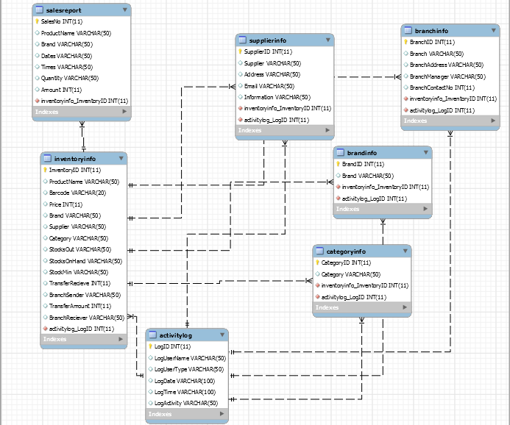

Diagram 1.2 Inventory Transaction

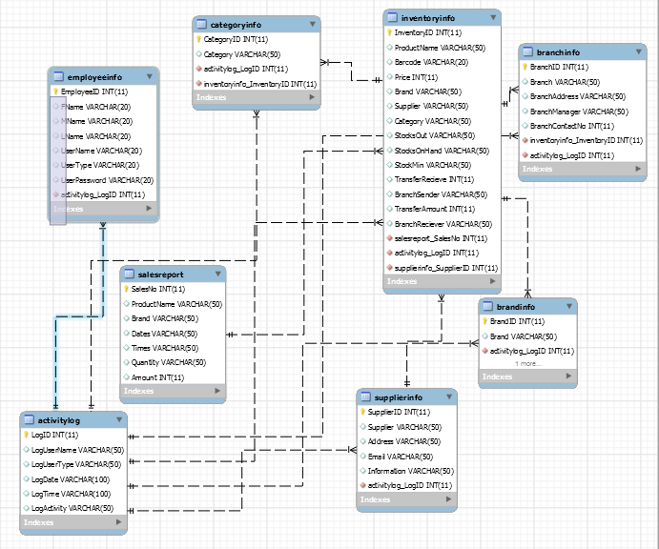

Diagram 1.3 Main Transactions

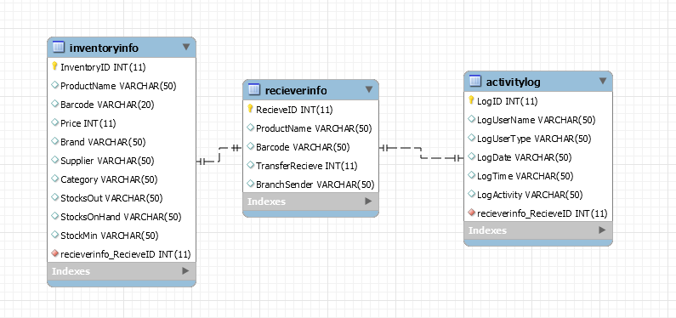

Diagram 1.4 Received Stocks

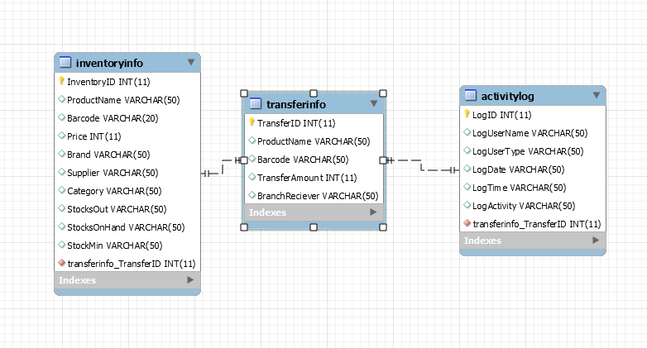

Figure 1.5 Transfer Stocks

Enhance Entity Relationship (ERR) Database

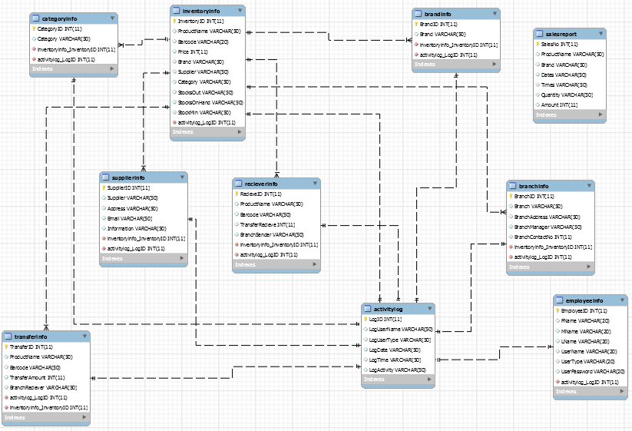

Figure 2

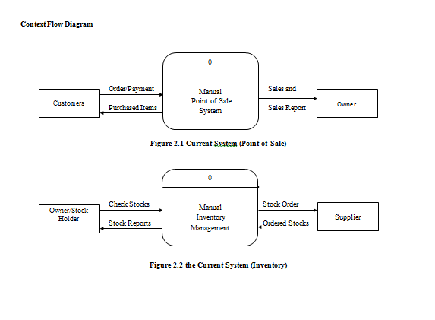

Figure 3.2 the Current System (Inventory)

Figure 3.1 the Current System (Point of Sale)

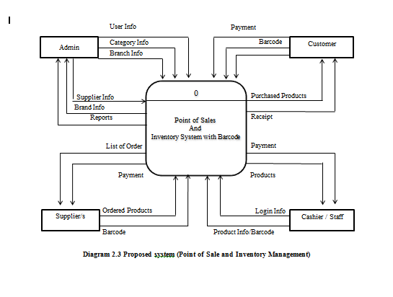

Figure 3.3 Proposed System (Point of Sale and Inventory Management)

System Lay Out

Diagram 3

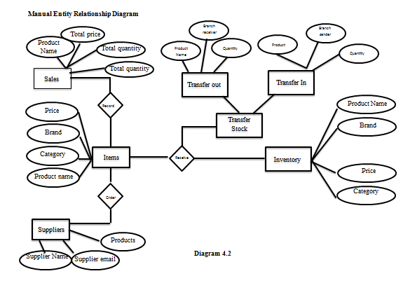

Diagram 4.1

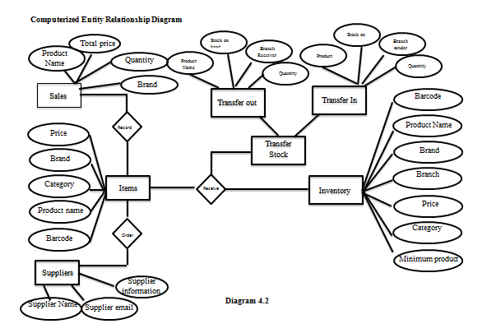

Data Dictionary

|  |  |  |
| --- | --- | --- |
| Name | Data Type | Description |
| EmployeeID | Int Primary Key | This is the Unique Identifier of the Employee |
| FName | Varchar | This describes the FirstName of the Employee |
| MName | Varchar | This describes the MiddleName of the Employee |
| LName | Varchar | This describes the LastName of the Employee |
| UserName | Varchar | This is  identification used by a person to access the system |
| UserType | Varchar | This is describe what level the employees is |
| UserPassword | Varchar | This is a word or phrase that must be used to gain access to the system |

Table 1.1 Employee Database

|  |  |  |
| --- | --- | --- |
| SupplierID | Int Primary Key | This the Unique Identifier of the Supplier |
| Supplier | Varchar | This is Name of the supplier |
| Address | Varchar | This is Address of the Supplier |
| Email | Varchar | This is the Email of the supplier |
| Information | Varchar | This is the information about the Supplier |

Table 1.2 Supplier Database

|  |  |  |
| --- | --- | --- |
| BranchID | Int Primary Key | This the Unique Identifier of the Branch |
| Branch | Varchar | This is the name of the supplier |
| BranchAddress | Varchar | This is the Address of the supplier |
| BranchManager | Varchar | This is the name of manager in other Branch |
| BranchContactNo | Int | This is the Contact Number of other branch |

Table 1.3 Branch Database

|  |  |  |
| --- | --- | --- |
| BrandID | Int Primary Key | This is the Unique Identifier of the Brand |
| Brand | Varchar | This is the Name of brand |

Table 1.4 Brand Database

|  |  |  |
| --- | --- | --- |
| LogID | Int Primary Key | This is the Unique Identifier of in the audit trail |
| LogUserName | Varchar | This is the Name of user that logged on the system |
| LogUserType | Varchar | This is the Type of user that logged on the system |
| LogDate | Date | This is the Date of user that logged on the system |
| LogTime | Time | This is the Time of user that logged on the system |
| LogActivity | Int | This is the action the user that logged on the system |

Table 1.5 Activity Log Database

|  |  |  |
| --- | --- | --- |
| SalesNo | Int Primary Key | Unique Identifier Of the sales report |
| ProductName | Varchar | This is the Name of the Product |
| Brand | Varchar | This is the Name the product was sold |
| Dates | Date | This is the Date the product was sold |
| Time | Time | This is the time the product was sold |
| Quantity | Int | This quantity the product that sold |
| Amount | Int | This is the amount of product was sold |

Table 1.6 Sales Report Database

|  |  |  |
| --- | --- | --- |
| RecieveID | Int Primary Key | Unique Identifier Of the sales report |
| ProductName | Varchar | This is the Name of the Product |
| Barcode | Varchar | This is the Name of the product in barcode |
| TransferRecieve | Int | This is the number of items Received |
| BranchSender | Varchar | This is the Name of the branch sender |

Table 1.7 Receive Stock Database

|  |  |  |
| --- | --- | --- |
| TransferID | Int Primary Key | Unique Identifier Of the sales report |
| ProductName | Varchar | This is the Name of the Product |
| Barcode | Varchar | This is the Name of the product in barcode |
| TransferAmount | Int | This is the number of items transferred to the branch |
| BranchReciever | Varchar | This is the Name of the branch receiver |

Table 1.8 Transfer Stock Database

|  |  |  |
| --- | --- | --- |
| Name | Data Type | Description |
| InventoryID | Int Primary Key | This is the Unique Identifier of the Employee |
| ProductName | Varchar | This describes the Name of the Product |
| Barcode | Varchar | This describes the Product as a barcode |
| Price | Int | This describes the price of the product |
| Brand | Varchar | This is the brand of the product |
| Suppleir | Varchar | This is the supplier of the product |
| Category | Varchar | This is the category of the product |
| StocksOut | Varchar | This is the number of the products that were sold |
| StocksOnHand | Varchar | This is the number of the products on hand |
| StockMin | Varchar | This is the number of the product’s minimum |

Table 1.9 Inventory Database

|  |  |  |
| --- | --- | --- |
| Name | Data Type | Description |
| CategoryID | Int Primary Key | This is the Unique Identifier of the Employee |
| Category | Varchar | This is the name of the category |

Table 1.10 Category Database

Results and Discussions

How did FEELMORE ENTERPRISE begin?

“Mga 2010 yung sa bacoor nag bukas kaso yung iba hindi alam kung kalian”

How many products do you have?

“More than 1000 plus”

How many customers buy product from you in a day?

“40 plus”

Who can access the current system you are using?

“Admin, owner, cashier, stock holder and staff”

What kind of system do you use when the customer buys a product from your store?

“Manually, by writing down the purchase product in a hand written reciept “

What part of the system has been difficult in using your current system?

“Nahihirapan kami dun sa inventory naming kasi hindi naming alam kung may stock pa kami.”

How do you purchase your products?

Yung sa bacoor kasi sa ibang bansa kumukuha ng stock.

What problem does your company encounter in your current POS and Inventory system?

“ Oh, minsan kasi nag kukulang na ung inventory, so hindi na monitory ung inventory tapos may mag oorder kulangna pala ung anu kulang na ung stock item ang gagawin hindi naman agad nakakapag deliver ung supplier dahil sa ibang bansa pa galing ehh. “

Who is the owner of FEELMORE?

“Si Mr Celbert Buliag.”

How is your currently Point of sale?

“Medyo hirap kami kasi manual bali sinusulat naming sa resibo then before magclose nilalagay sa log book.”

How is your currently Inventory?

“After malagay sa log book ichecheck naming kung akma ba yung product stock na nabenta namin bali chinecheck naming yung log book and yung data naming sa excel.”

Conclusion and Recommendation

The inclusion of Sales and inventory of FEELMORE provides a sales and inventory system that is capable of providing and easy access sales and inventory conditions to customers and partners. These are problems that FEELMORE encountered. One of that is, their records don't coincide in their manually recorded data's. Another problem is that they often forgot to record the products that have been sold. The solution to these problems is to make automated and computerized sales and inventory system. Making this system can minimize their time period and can help them process their inventory easily. It is a hassle free and an easy access system. The system can add, delete and update data’s. It is also has a transaction process so that in every product that the costumer will buy, will automatically recorded in their inventory. The flow on how system works is that the user must input his or her username and password in for him to access the inventory, transaction process and adding, updating and deleting of data. The inventory consists of the list of the products, the quantity and its price. While the transaction process consist of inputting data such as the Item name, Item price and the quantity of the product, also the amount receive from the customer.

Conclusion

Sales and Inventory System software developed for a company has been designed to achieved maximum efficiency and reduce the time taken to handle the Payroll activity. It is designed to replace an existing manual record system thereby reducing time taken for calculations and for storing data. This system uses Visual Studio as front end and MySQL as a backend for the database. The system is strong enough to withstand regressive daily operations under conditions where the database is maintained and cleared over a certain time of span. The implementation of the system in the organization will considerably reduce data entry, time and also provide readily calculated reports.

Recommendations

Inventory software programs now on the market let you track usage, calculate when you need to reorder, and analyze inventory. You can even control inventory right at the cash register with point of sale. Point of sale records each sale a cahier has done, whereas in result the inventory records are always up to date. By using Point of sale and inventory management system you get much more information about the sale than you could gather with a manual system. By running reports, you can make better decisions about ordering and merchandising. With a point of sale you can easily analyze sales data, and adjust purchasing levels accordingly. You can improve pricing accuracy by integrating barcode scanners. In summary, a point of sale is an all in one way of keeping track of your business's cash flow.

References

https://theses.lib.vt.edu/theses/available/etd-9597-162630/unrestricted/ch5-src.PDF

http://www.academia.edu/16863814/Sales_and_Inventory_System_Thesis_Documentation

https://www.coursehero.com/file/p21njr3/Summary-The-inclusion-of-Sales-and-Inventory-System-into-the-Pharmacia-Josefa/

Appendices

Appendix A. Title page

POINT OF SALE AND INVENTORY MANAGEMENT SYSTEM WITH BARCODE SCANNER FOR FEELMORE ENTERPRISE –BACOOR BRANCH

A Project

Presented to the Faculty of

Information and Communications Technology Program

In Partial Fulfilment

of the Requirements for the Degree

Bachelor of Science in Information Technology

Appendix B. Acceptance letter

Appendix C. GANTT CHART

|  |  |  |  |  |  |  |  |  |  |  |  |  |  |  |  |  |
| --- | --- | --- | --- | --- | --- | --- | --- | --- | --- | --- | --- | --- | --- | --- | --- | --- |
| MONTH | JUNE | | | | JULY | | | | AUGUST | | | | SEPTEMBER | | | |
| ACTIVITY |
| Planning |  |  |  |  |  |  |  |  |  |  |  |  |  |  |  |  |
| Research about Point of sales and inventory  with barcode |  |  |  |  |  |  |  |  |  |  |  |  |  |  |  |  |
| Tried applications to produce Point of sale and  inventory |  |  |  |  |  |  |  |  |  |  |  |  |  |  |  |  |
| Came up with the Point of sale and inventory |  |  |  |  |  |  |  |  |  |  |  |  |  |  |  |  |
| Brainstormed for point of sales and inventory theme |  |  |  |  |  |  |  |  |  |  |  |  |  |  |  |  |
| Created a theme for the point of sale and inventory |  |  |  |  |  |  |  |  |  |  |  |  |  |  |  |  |
| Divided the tasks for documentation |  |  |  |  |  |  |  |  |  |  |  |  |  |  |  |  |
| -Introduction and background of the problem |  |  |  |  |  |  |  |  |  |  |  |  |  |  |  |  |
| -Overview of the current state of technology |  |  |  |  |  |  |  |  |  |  |  |  |  |  |  |  |
| -Objectives of the Study |  |  |  |  |  |  |  |  |  |  |  |  |  |  |  |  |
| -Scope and Limitations |  |  |  |  |  |  |  |  |  |  |  |  |  |  |  |  |
| Started to look for a Psychiatrist |  |  |  |  |  |  |  |  |  |  |  |  |  |  |  |  |
| Tried to look for a company |  |  |  |  |  |  |  |  |  |  |  |  |  |  |  |  |
| Planning / preparation |  |  |  |  |  |  |  |  |  |  |  |  |  |  |  |  |
| Title Proposal was accepted |  |  |  |  |  |  |  |  |  |  |  |  |  |  |  |  |
| Brainstormed for System ideas |  |  |  |  |  |  |  |  |  |  |  |  |  |  |  |  |
| Distribution of tasks |  |  |  |  |  |  |  |  |  |  |  |  |  |  |  |  |
| Started the documentation |  |  |  |  |  |  |  |  |  |  |  |  |  |  |  |  |
| Start to Design and Develop the System |  |  |  |  |  |  |  |  |  |  |  |  |  |  |  |  |
| Present the 1st prototype to the client |  |  |  |  |  |  |  |  |  |  |  |  |  |  |  |  |
| Develop necessary changes to the system |  |  |  |  |  |  |  |  |  |  |  |  |  |  |  |  |
| Production of the 2nd prototype |  |  |  |  |  |  |  |  |  |  |  |  |  |  |  |  |
| Present the improved prototype |  |  |  |  |  |  |  |  |  |  |  |  |  |  |  |  |
| Develop necessary changes to the system |  |  |  |  |  |  |  |  |  |  |  |  |  |  |  |  |
| Finalize the system |  |  |  |  |  |  |  |  |  |  |  |  |  |  |  |  |
| Test the system for errors |  |  |  |  |  |  |  |  |  |  |  |  |  |  |  |  |

Appendix d. Actual Project Expenses

Budgetary Estimate

|  |  |  |
| --- | --- | --- |
| Quantity | Specifics | Approximate Cost |
| 50 | Transportation | P 500 |
| 150 | Print | P 200 |
| Load | Internet | P 150 |
| 30 | Food | P 300 |
| 1 | Barcode Scanner | P840 |
|  | Total | P1990 |

The following resources will be used from the beginning until the completion of the entire project.

Appendix e.USER’s MANUAL

User’s Manual

Login Form



1

1. **Login Button**

- Button use to login to the system, but first provided the correct credentials of Username and Password textboxes.

Main Form



4

3

2

1

1. **File Maintenance Ribbon**

- This ribbon will direct the user to the file maintenance module, this module can add, update and delete employee, supplier, branch, brand and category information’s.

1. **Point of Sale Ribbon**

- This ribbon will direct the user to the point of sale module which can be used for payment.

1. **Inventory Ribbon**

- This ribbon will direct the user to the inventory module which can add, update, delete product information, see products that needs to be restock, see products that was sent by other branches and also see what products was sent to other branches.

1. **Report Ribbon**

- This ribbon will direct the user to the Report module which shows all the sales done, and all the action done by the user.

Employee Maintenance Form



DataGridView

4

3

2

1

1. **Add New Employee Button**

- After filling up all required field, the user now should click the add button to save the employee information.

1. **Update Button**

- To update data double click on datagridview then update all the field you want to update.

1. **Clear Button**

- To clear all the fields

4. Delete Button

* To delete data double click on datagridview then then click the delete button.

Category Maintenance Form



DataGridView

2

4

3

1

1. **Add New Employee Button**

- After filling up all required field, the user now should click the add button to save the employee information.

1. **Update Button**

- To update data double click on datagridview then update all the field you want to update.

1. **Clear Button**

- To clear all the fields

4. Delete Button

* To delete data double click on datagridview then click the delete button.

Supplier Maintenance Form



DataGridView

4

3

2

1

1. **Add New Employee Button**

- After filling up all required field, the user now should click the add button to save the employee information.

1. **Update Button**

- To update data double click on datagridview then update all the field you want to update.

1. **Clear Button**

- To clear all the fields

4. Delete Button

* To delete data double click on datagridview then then click the delete button.

Branch Maintenance Form



DataGridView

2

4

3

1

1. **Add New Employee Button**

- After filling up all required field, the user now should click the add button to save the employee information.

1. **Update Button**

- To update data double click on datagridview then update all the field you want to update.

1. **Clear Button**

- To clear all the fields

4. Delete Button

* To delete data double click on datagridview then click the delete button

Brand Maintenance Form



DataGridView

3

4

2

1

1. **Add New Employee Button**

- After filling up all required field, the user now should click the add button to save the employee information.

1. **Update Button**

- To update data double click on datagridview then update all the field you want to update.

1. **Clear Button**

- To clear all the fields

4. Delete Button

* To delete data double click on datagridview then then click the delete button.

Point of Sale Form



DataGridView

1

2

3

4

1. **Barcode Textbox**

- In this textbox you can add the barcode of the product. Shortcut key to go into barcode is “ESC”.

1. **Quantity Textbox**

- In this textbox you can add the quantity of the product. Shortcut key to go into barcode is “TAB”.

1. **Payment Textbox**

- In this textbox you can add the payment of the customer. Shortcut key to go into barcode is “SHIFT”.

4. Search Button

* In this button you can search for the product details.

5. Null item

* Press “Home” then enter manager password and select item to be deleted.

Inventory Maintenance Tab



4

3

2

1

DataGridView

5

1. **Add New Employee Button**

- After filling up all required field, the user now should click the add button to save the employee information.

1. **Update Button**

- To update data double click on datagridview then update all the field you want to update.

1. **Clear Button**

- To clear all the fields

4. Delete Button

* To delete data double click on datagridview then then click the delete button.

5. Product Restock Button

* To see product that need to be restock click the button Product restock.

Inventory Transfer Stock Tab



2

3

2

1

1. **Transfer In Button**

- Fill up the required fields and click Transfer In Button to add the products.

1. **Clear Button**

- Click clear button to clear all the fields.

1. **Transfer Out Button**

- Fill up the required fields and click Transfer out Button to send the products.

Sale Report Form



2

3

1

1. **Date Pick**

- Click the dates you want to show

1. **Search Textbox**

- After choosing which dates click search to preview all the sales done on the dates you picked.

1. **Print Button**

- To print click the print button.

Audit Trail Form



1

2

3

1. **Category Combo box**

- Click the combo box and choose which category you want

1. **Search Textbox**

- After choosing which category search for the action you want to search.

1. **Print Button**

- To print click the print button.

Appendix E. Curriculum Vitae of Researchers

Curriculum Vitae of

EDUCATIONAL BACKGROUND

|  |  |  |
| --- | --- | --- |
| Level | Inclusive Dates | Name of school/ Institution |
| Tertiary |  |  |
| High School |  |  |
| Elementary |  |  |

PROFESSIONAL OR VOLUNTEER EXPERIENCE

|  |  |  |
| --- | --- | --- |
| Inclusive Dates | Nature of Experience/  Job Title | Name and Address of Company or Organization |
|  |  |  |
|  |  |  |
|  |  |  |
|  |  |  |

AFFILIATIONS

|  |  |  |
| --- | --- | --- |
| Inclusive Dates | Name of Organization | Position |
|  |  |  |
|  |  |  |

SKILLS

|  |  |  |
| --- | --- | --- |
| SKILLS | Level of Competency | Date Acquired |
|  |  |  |
|  |  |  |
|  |  |  |

TRAININGS, SEMINARS OR WORKSHOP ATTENDED

|  |  |
| --- | --- |
| Inclusive Dates | Title of Training, Seminar or Workshop |
|  |  |